LAB# 2


Submitted by:

Submitted by:

Name | Registration No.
Muhammad Abdullah | FA24-BSE-042

Submitted to: Dr Rubina Adnan
Course: Database systems
Dated: March 5, 2026.

DEPARTMENT OF COMPUTER SCIENCE
COMSATS UNIVERSITY ISLAMABAD,
ISLAMABAD CAMPUS

Task 1
Write a SQL statement that displays the last_name, job_id, hire_date, and employee_id for each employee, with the employee_id appearing first. Rename HIRE_DATE column as STARTDATE.

Output:

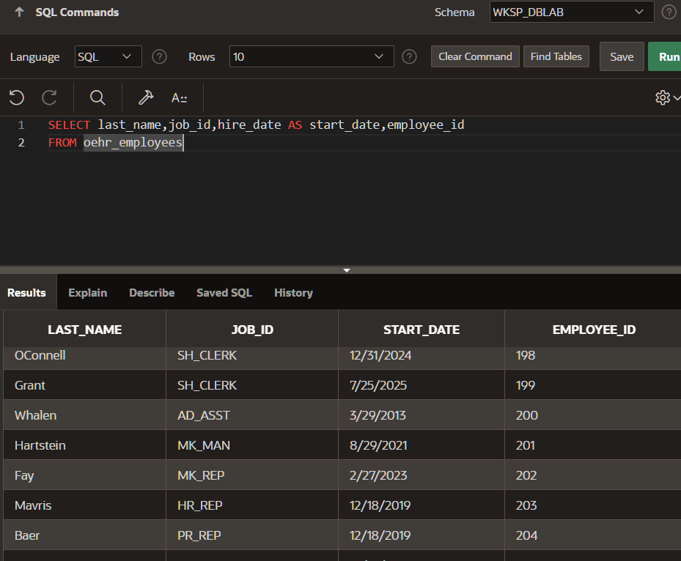

TASK 2
Write a SQL statement that displays the last_name concatenated with the job_id (separated by a comma and space) of all the employees and name the columns as Employee and Title.

Output:
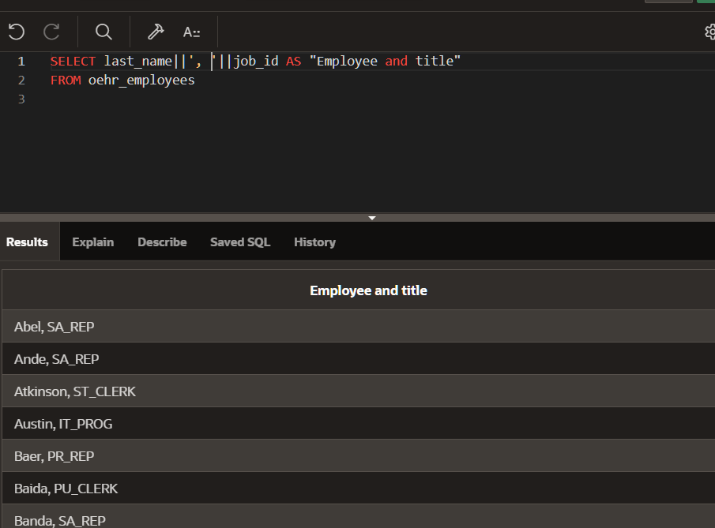

TASK 3
Write a SQL statement that instead of retrieving all rows from employees table for all job_id’s, find only distinct job_id’s.

Output:

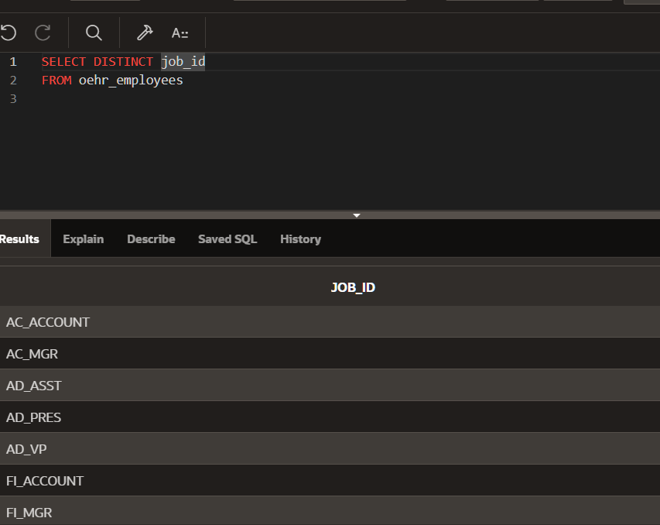

TASK 4
Write a SQL statement that shows first_name and last_name of all employee after concatenation them. Use space as the separator. Name the resultant column as “Name”.

Output:

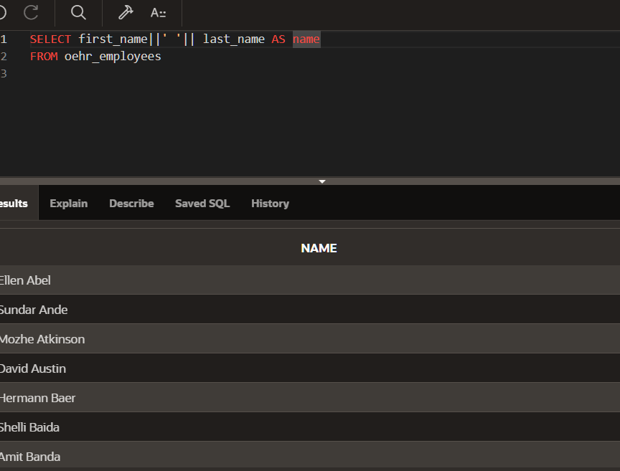
TASK 5
Write a SQL statement that displays first_name and the annual salary of employees.

Output:

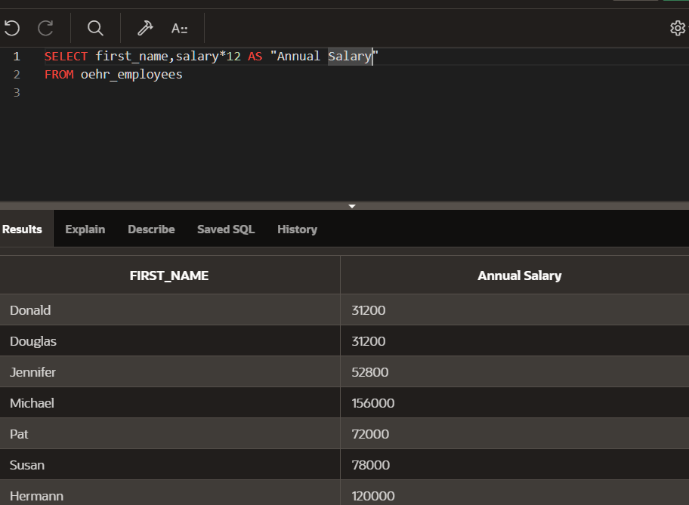

TASK 6
Write a SQL statement that displays the structure of the departments table.

Output:

